**Set Up a WordPress Instance for an Organization**

**Description:** An organization publishes blogs and provides documentation services for other businesses and technologies. Agenda:

* Set up a live WordPress instance to publish blogs
* Set up a WordPress instance that can be used for development and testing purposes so that any work done on this instance will not impact the live blog
* Configure the WordPress instance for development and testing purposes, which will be available only for the business hours (9 AM–6 PM)
* Monitor the health of the WordPress instance

**Step 1: Create a CloudFormation new stack**

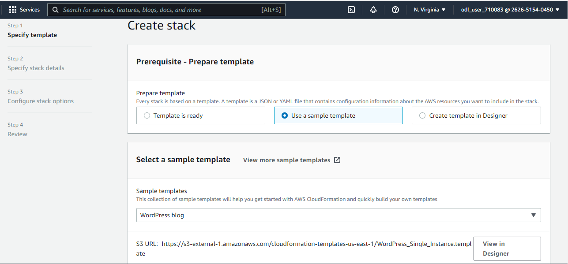

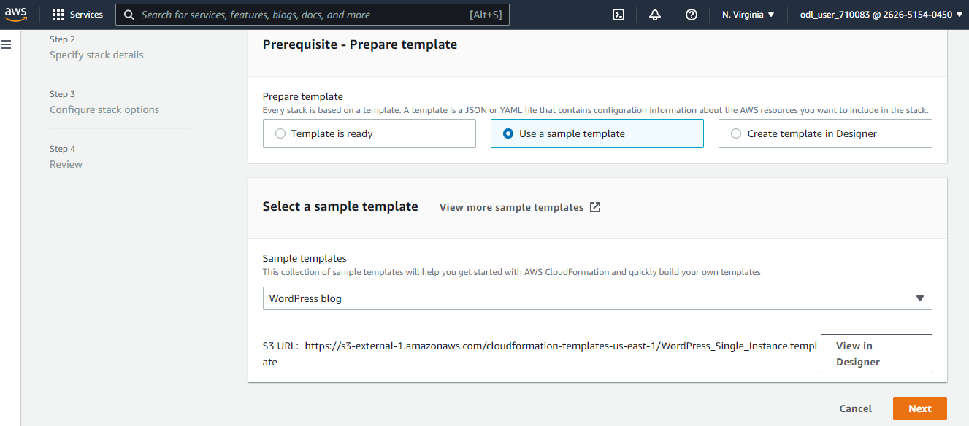

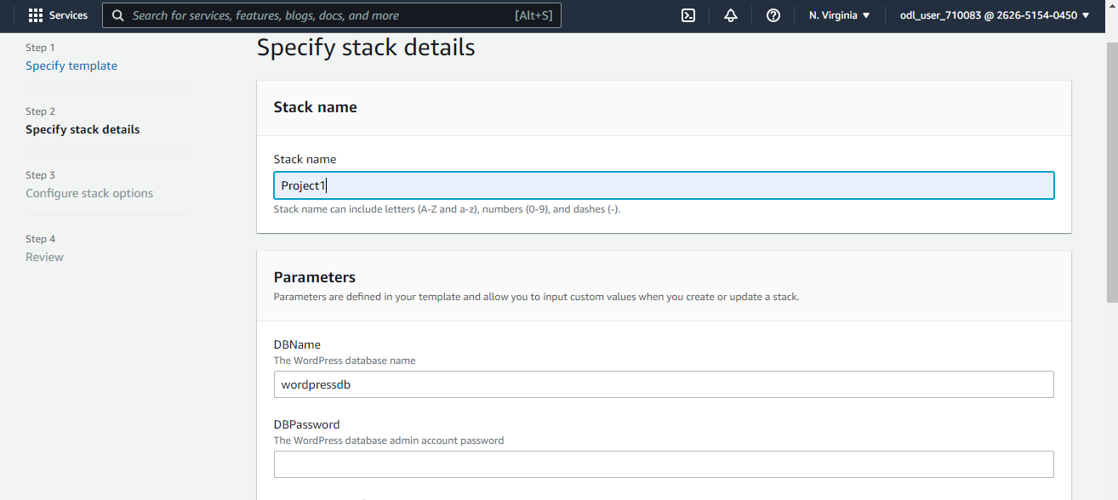

**Step 2: Create an AMI of the WordPress instance**

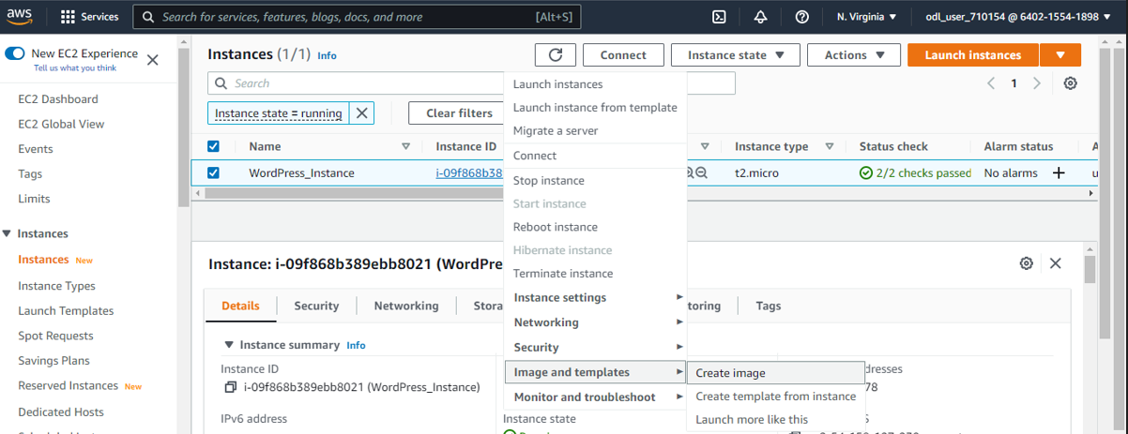

**Step 3: Create launch configuration**

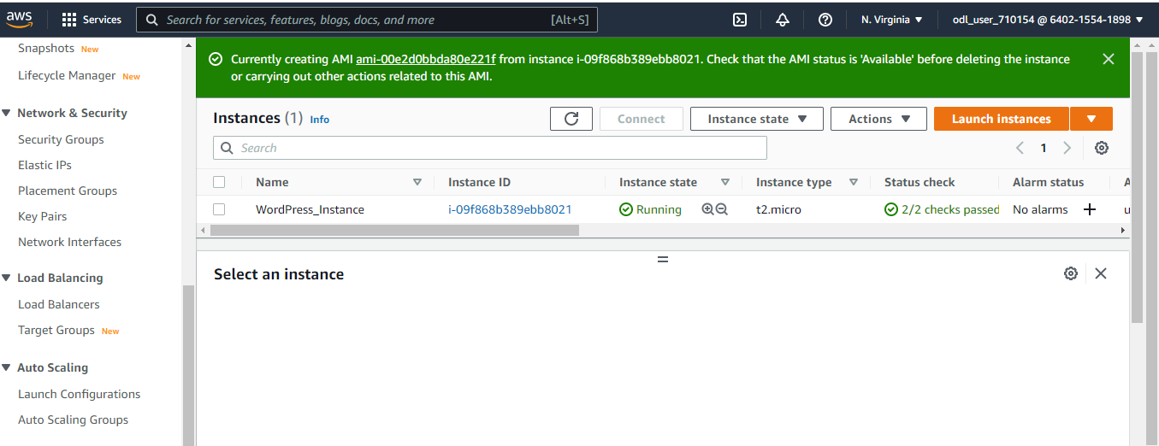

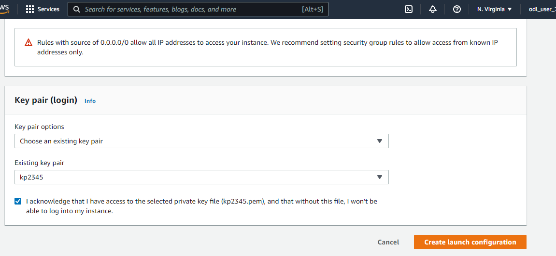

**Step 4: Configure the new WordPress instance to shut down automatically**

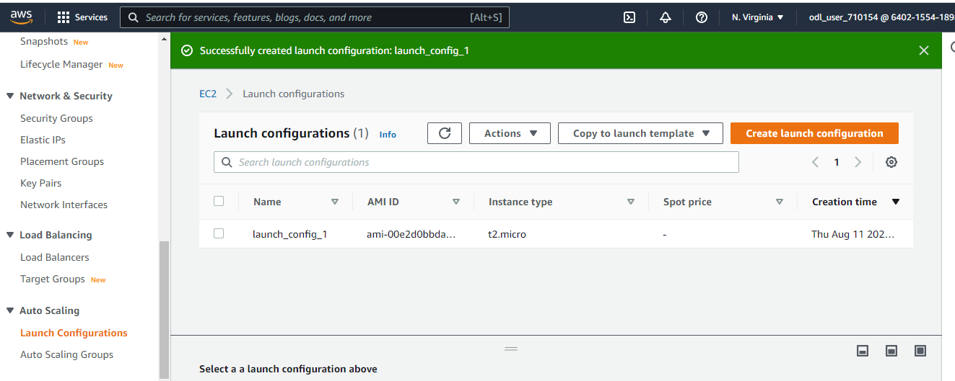

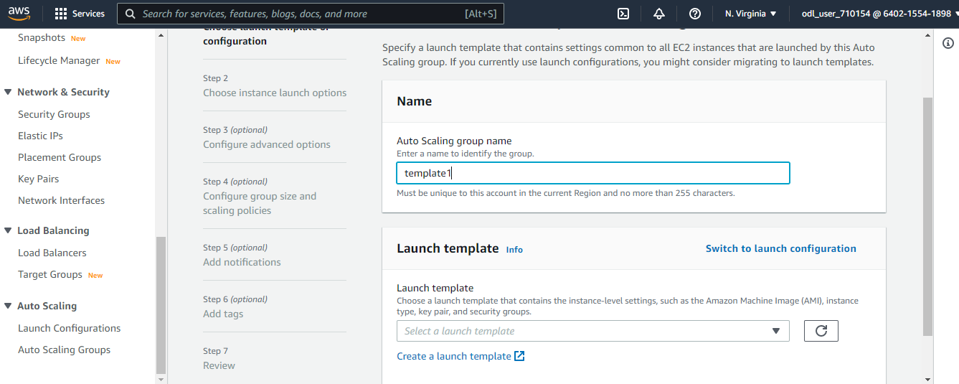

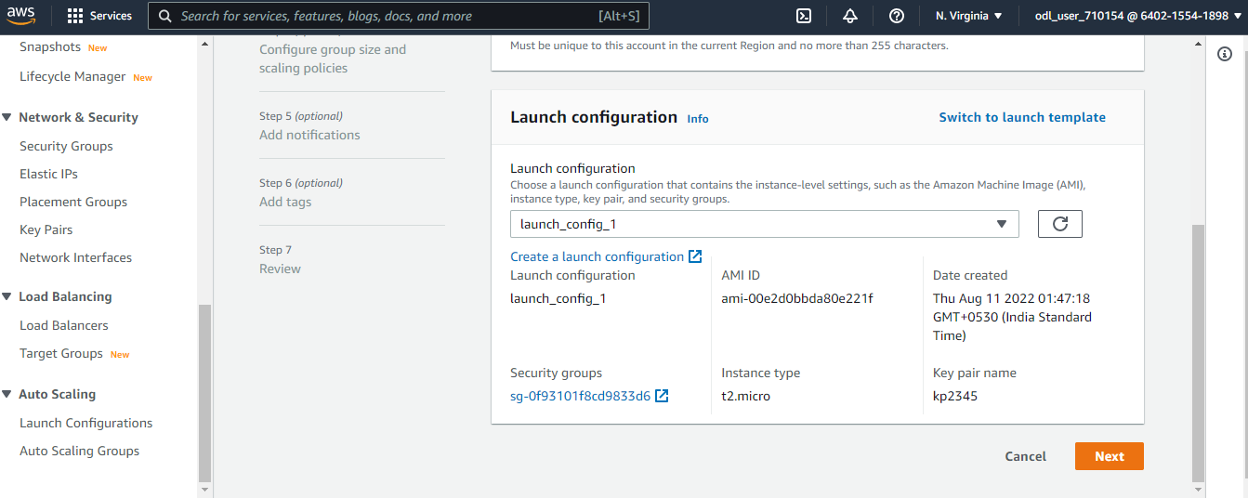

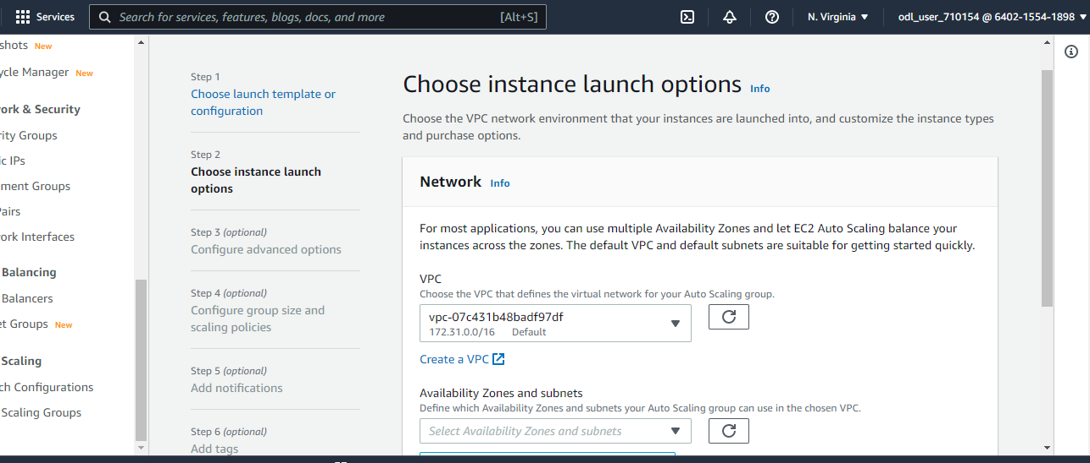

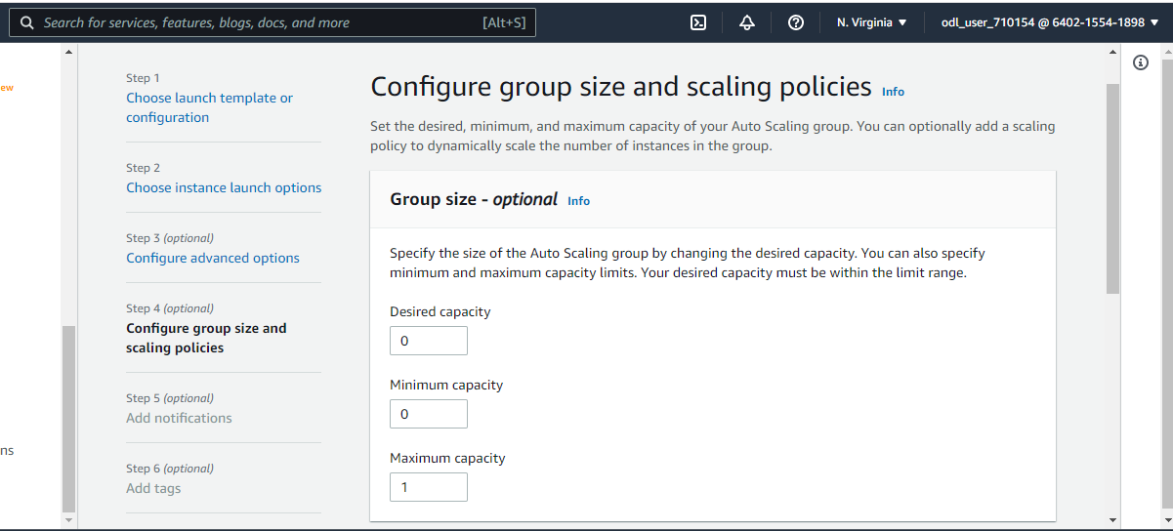

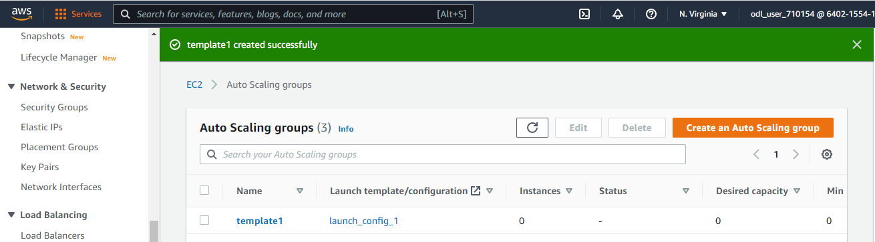

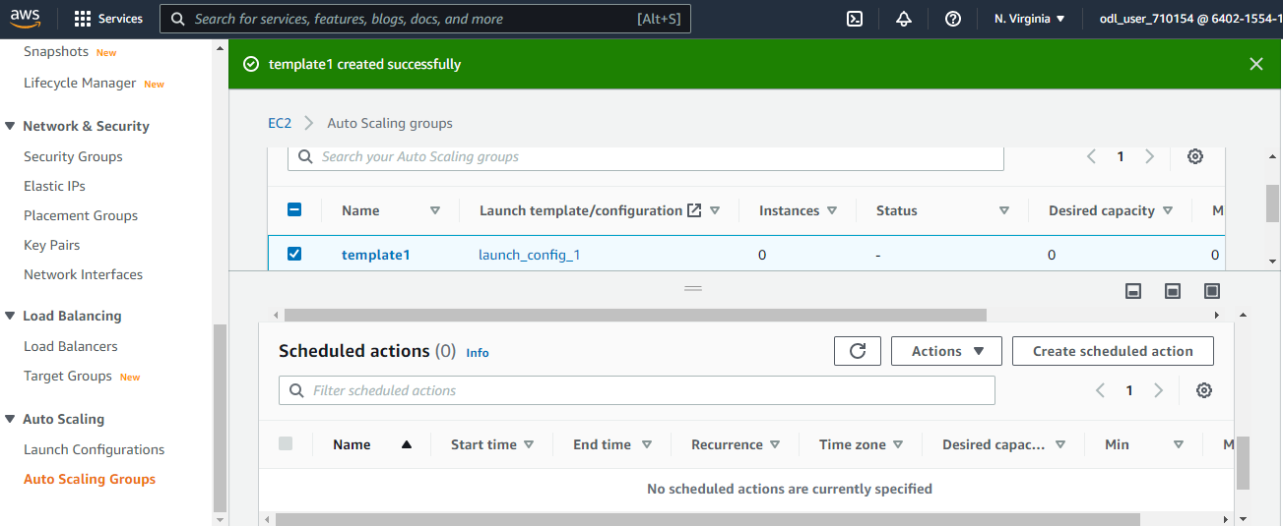

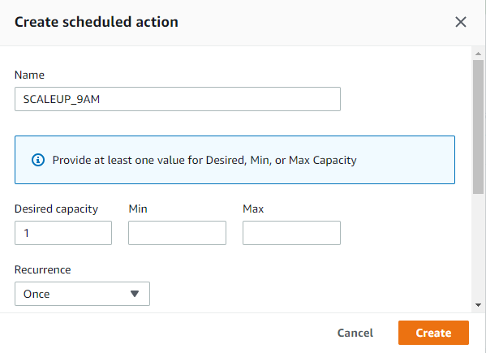

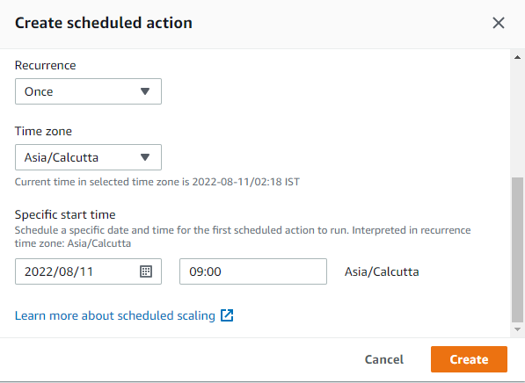

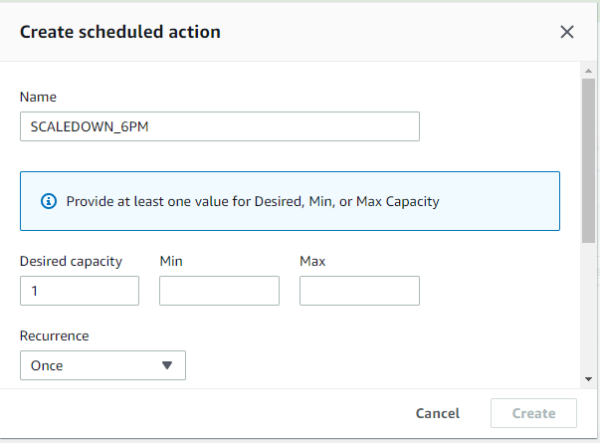

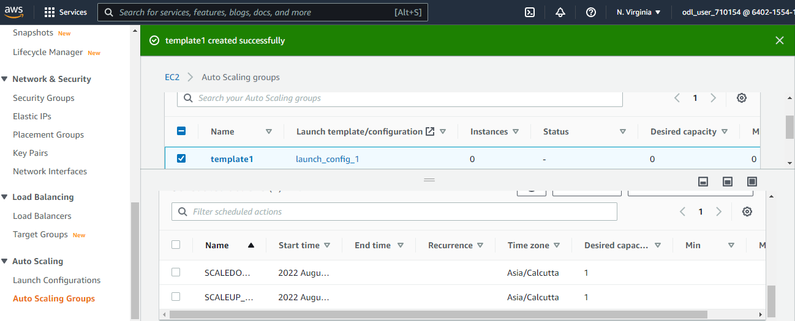

**Step 5: Monitoring the Solution using Availability Monitoring feature of the R53**

